

*SAGE Business Cases*gives you access to thousands of cases that will inspire you to develop your own best practices and prepare for professional success!

Use this platform discovery map to learn more about the platform in relation to a topic that you’d like to learn more about. There is a model completed overleaf: use this as an example to guide you as you complete your own.

**At your institution, who could support you as you continue to enhance your knowledge and skills on this topic?**

**Let’s get started!**

**What business and management topic would you like to learn more about?**

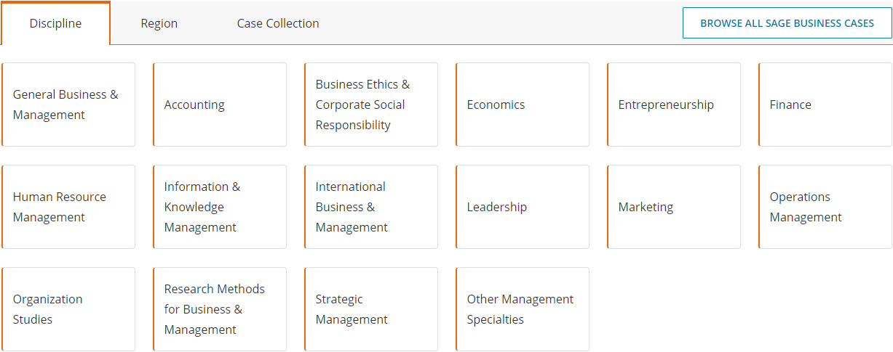

**Does the ‘Browse by Discipline’ menu have an entry related to your topic?**

**How has the ‘Browse by Discipline’ menu helped you?**

You can explore more of our training resources [**here**](https://uk.sagepub.com/en-gb/eur/training-resource-centre).

**What do you like about this case? Has it helped you understand your chosen topic?**

**Where can you find the icons for you to cite, share and add this case to a list?**

**Run a search for your chosen topic. What key word search terms did you use? Could you apply any filters?**

**Open one of the cases that looks interesting to you and note the title.**

**At your institution, who could support you as you continue to enhance your knowledge and skills on this topic?**

*Library staff. My colleagues.*



Platform discovery map: example

**Let’s get started!**

**What business and management topic would you like to learn more about?**

*Job interview skills / staff recruitment*



**How has the ‘Browse by Discipline’ menu helped you?**

**Does the ‘Browse by Discipline’ menu have an entry related to your topic?**

*Yes, ‘Human Resource Management’, and subtopics of ‘Recruitment & Retention’, ‘Human Resource Strategy & Planning’ and ‘Talent Management’.*

You can explore more of our training resources [**here**](https://uk.sagepub.com/en-gb/eur/training-resource-centre).

**What do you like about this case? Has it helped you understand your chosen topic?**

*I like this case because it contains lots of ideas for discussion questions and tasks to use with students, and engage them in the process of staff selection. This will help students reflect on their own experiences when applying for jobs.*

**Where can you find the icons for you to cite, share and add this case to a list?**

*Top-right of the case page. I also created a list of other cases on my topic* [*here*](http://sk.sagepub.com/profile/sharedlist/43872)*.*

*As I’m new to SAGE Business Cases, this menu has given me a good overview of the subjects that are related to my topic. It has also helped me to consider alternative key word search terms.*

**Run a search for your chosen topic. What key word search terms did you use? Could you apply any filters?**

*‘Recruiting staff’, ‘Job interview skills’*

*I want ideas for how to use cases with students, so I applied the teaching notes filter.*

**Open one of the cases that looks interesting to you and note the title.**

*‘Southwood School: A Case Study in Recruitment and Selection’*