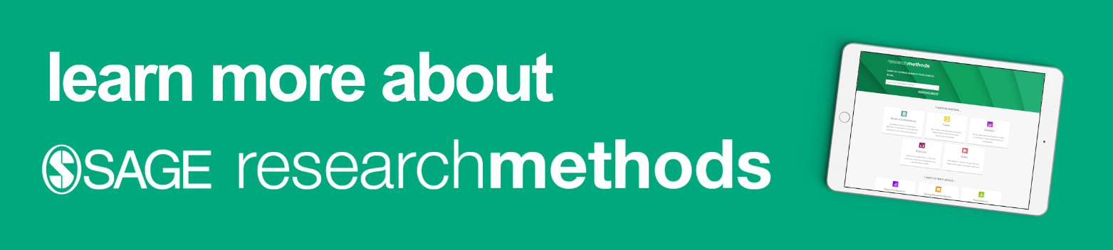

Training activity:

Activity
Aim: To build your confidence and experience in using SAGE Research Methods for future study and research projects.
Task: You are going to create a reading list within the SAGE Research Methods platform:
- If you are a student or a researcher, this could be related to a current assignment or project that you are working on;
- If you are Faculty, this could be for a lecture or module that you are teaching, or for your own research project;
- If you are a Librarian, this could be for an information skills workshop that you are hosting, or for your own interest.

Using what you know about SAGE Research Methods, explore the platform to find resources to add to your reading list, and complete the table on the next page of this worksheet:
- Decide what research topic you are going to use for this activity; identify some key words that you might use in your searches.
- Using the search and browse options, explore the SAGE Research Methods platform to find some suitable resources on your chosen topic. Spend some time reading these resources to see which ones you find most interesting, relevant or useful.
- Using the table on the next page, make a note of at least two resources that you could add to your list.
- Consider why you like the resource you have chosen, and how you could use it. Make some notes in the columns provided.
- If you haven’t done so already, create your free profile, then add your chosen resources to a new reading list.

When looking for resources on your chosen research topic, you may like to apply some of the following criteria:
- Resources that introduce or define the research topic;
- Resources that provide instructions in how to go about the research topic;
- Resources that incorporate reflection activities or exercise questions;
- Resources from well-known authors and academics;
- Anything else you find interesting.

Resource title and content type | Why do I like this resource? | How could I use this resource?

Model activity table: examples based upon a librarian teaching about the topic of “systematic review”

Resource title and content type | Why do I like this resource? | How could I use this resource?
Project Planner: What Is A Systematic Review? | Sets the research process out clearly defined research stages.  Contains checklists and questions for students and researchers to consider before they move on to the next research stage.  Links out to explore other content within the platform. | Building on knowledge from the short definition given in the Methods Map, students can read this Project Planner entry, and explore some of the links to learn about related concepts and discover other content on the platform.  Explore how the systematic review fits into the research stage of ‘Data Collection’ and the wider process.
Book chapter: ‘Synthesising Evidence: Systematic Reviews, Meta-Analysis and Preference Analysis’ In: Research Methods for Clinical and Health Psychology | ‘One-stop shop’ resource containing enough detail of how to do a systematic review, and some of the key debates in this area. Includes: history of development; detailed considerations and things to be aware of; meta-analysis; combining qualitative and quantitative evidence. | ‘Essential’ reading on the list because it covers so much detail in one chapter.  The list of 6 revision questions gets students to recall knowledge from the chapter, which could be used for an in-class discussion.
Book chapter: ‘Practical Systems for Systematic Reviews of Research to Inform Policy and Practice in Education’ In: Developing Educational Leadership | The EPPI-Centre is a centralised resource for people who wish to undertake and/or use the results of systematic reviews of research in education.  He details how the EPPI-Centre go about their process of systematic review, and the role it plays in supporting and facilitating research and researchers. | This book chapter gives students practical advice about undertaking systematic reviews in the context of a professional research centre. It encourages students to think beyond academic applications of the systematic review, so could be useful discussion tool for a seminar class.

